Bethold Section:

I embarked on three important goals.

**First Goal**

The first goal was to investigate the distribution of crimes per Month, week and day. By knowing how monthly crimes change per month, week and day; law enforcers can deploy new tactics in dealing with crimes over time.

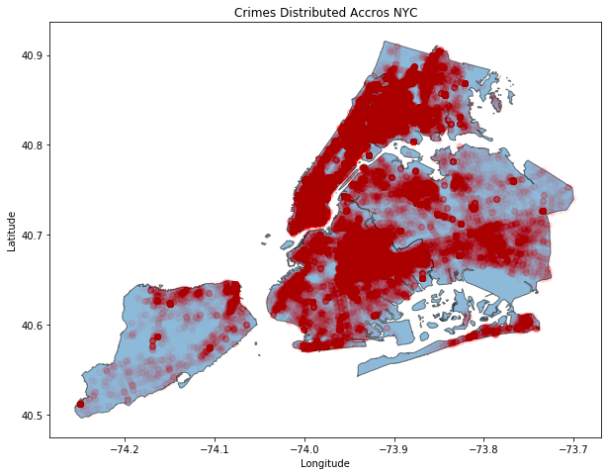

The above map shows the overall 2019 crimes distributed across NYC borough map

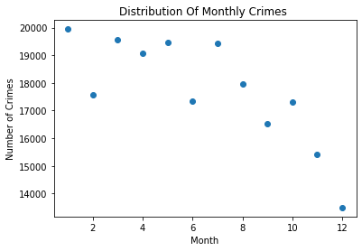 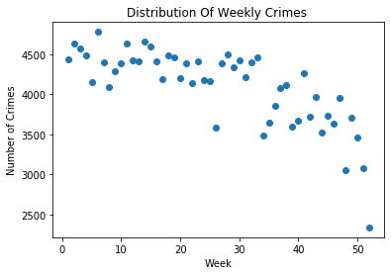

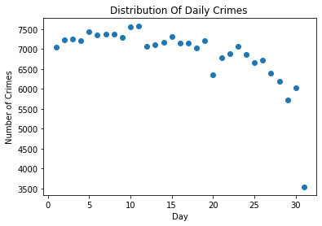

The above three graphs show the distribution of crimes per month, week and day. The overall trend in crime decrease in the year 2019 from January to December.

There are high number of crimes in January compared to the rest of the month. November and December having the lowest crimes possibly suggest the seasonal holydays that take place such Thanksgiving and Christmas influences crime occurrence. Particularly, since more time is spent with family, it is less likely for one to commit a crime.

**Second Goal**

The second goal was to find hotspot where there are daily crimes occurrence. I implement an algorithm to generate locations where crime occurred daily. I found there were 133 daily crime hotspots out of 120,000 unique locations in our 2019 crime data. The picture below shows the 133 locations where there are daily crimes. Some popular locations out of the 133 includes

* ALBEE square (Brooklyn)
* Queens boulevard expressway (Queens)
* Rockefeller center (Manhattan)
* FULTON MALL (Brooklyn)
* Gateway Dr
* Nostrand subway station
* JFK airport
* Trans Manhattan exp
* Bartow avenue (coop city mall, Bronx)

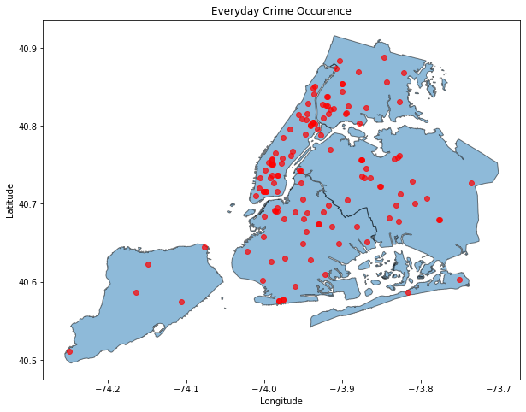

This is very important because such locations can be brought to public and lawmakers’ attention. This will call for extra safety tools to be implemented in such regions as well as an increase in police patrolling. More importantly, researchers can further investigate why there are so many crimes occurring daily in these regions. Thus, this will deepen our understanding in structuring our cities and ensuring its safety. Some research questions that could be further explored in the hotspot regions with daily crimes include education background, level of spirituality, security cameras installation, aides for the individuals in these regions, policies governing these areas, history of these regions.

**Second Goal**

The third goal was to classify level of offense as Felony, Misdemeanor and Violations giving the crime description. This might be useful for the arrest’s relative to really know the level of offense base on many crimes analyzed by the algorithm.